YORKSHIRE IN LITERATURE:
THE BRONTËS

The Brontë sisters
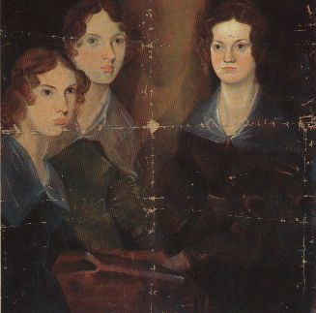
Charlotte (1816-1855), Emily (1818-1848) and Anne Brontë (1820-1849) are probably the most famous female 19th century authors who were born in Yorkshire. Their works quickly entered the canon of English literature.

Anne, Emily and Charlotte (left to right)
painted by their brother Branwell

The Brontë family and their home
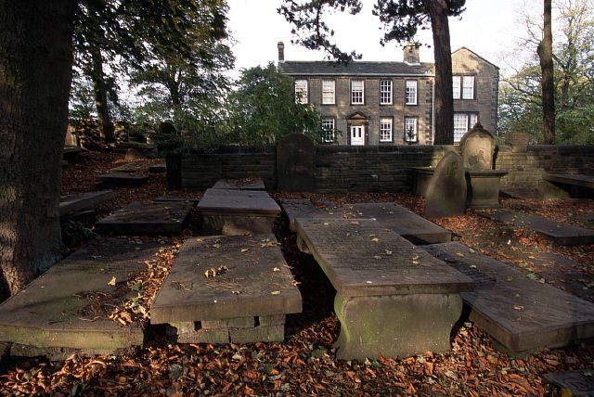
The sisters spent the most part of their lifetime in Haworth, West Yorkshire, a place which had a huge impact on their lives and literary works. Not least the moor- dominated landscape adjoining Haworth was to become an inspiration for their novels and poems later on. Although all the Brontë children were born in Yorkshire the family’s roots are Celtic, for their father Patrick was born in Ireland and mother Maria Branwell in Cornwall. Because Patrick Brontë was a clergyman, the family inhabited a parsonage in Haworth which can be visited today as the “Brontë Museum”. Apart from Charlotte, Emily and Anne, the Brontës had two more elder daughters Maria (1814-1825) and Elizabeth (1815-1825) who died very early and a son called Branwell (1817-1848). He likewise wanted to establish himself as a writer and even as a painter but did not succeed in it as well as his three sisters.
Early works and the first success
The Brontë parents, in particular Patrick Brontë, enjoyed writing, loved books and poetry. Therefore at an early age the children became acquainted with literature and the craft of writing when they were taught at home before attending school. In their childhood Emily, Anne, Charlotte and their brother Branwell began to create their own imaginary worlds “Angria” and “Gondal” about which they wrote down stories in tiny books. These early works known as the “Brontë juvenilia” were long kept secret by the Brontës and not all has survived.
Later during their time as governesses and teachers - experiences which to some extent would enter Charlotte’s and Anne’s novels - the three sisters kept on writing. In 1845 they decided to publish a book containing some of their poems. At their own expense they decided to publish the poems under the male pseudonyms Currer (Charlotte), Acton (Anne) and Ellis (Emily) Bell. Veiling their female authorship was intended to prevent rejection of the book but still this book did not prove to be a success. Only in 1847 did publishers immediately accept Emily’s novel Wuthering Heights and Anne’s Agnes Grey which at last brought about their sensational breakthrough. Charlotte’s The Professor was rejected but with Jane Eyre she, like her sisters, could celebrate her first literary success in the same year, too.

Charlotte Brontë
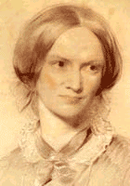
In contrast to Emily and Anne who died the following two years after the publication of their novels, Charlotte was able to continue a career as a writer. And although love and marriage is the most frequent topic in the Brontë’s literary world, Charlotte was the only sister who got married in real life.
After Jane Eyre (1847) another three novels were published: Shirley (1849), Villette (1853) and finally her first novel The Professor (1857). The story refers to Charlotte’s own experiences: during her stay in Belgium Charlotte fell in love with her professor Constantin Heger. In Jane Eyre, the female protagonist, an orphan, searches for respect and love. The model for “Lowood”, the strict school Jane is sent to, was Cowan Bridge, a school Charlotte and Emily attended together with their two elder sisters. Maria and Elizabeth became seriously ill there and died shortly after they were sent home.

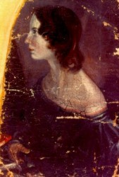
Emily Brontë
Her only novel Wuthering Heights (1847), which was filmed many times, might be the most famous work by one of the Brontë sisters. The story about the relationship of Catherine Earnshaw and the orphan Heathcliff is mainly based on imagination and compared to the novels of her two sisters considered the least autobiographical. Emily is often attributed the greatest literary talent.

Anne Brontë
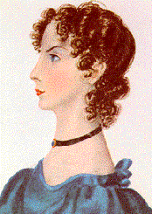
After her novel Agnes Grey (1847), a story about the life of a governess, she wrote The Tenant of Wildfell Hall (1848). In this second work a young woman, Helen, marries a man who becomes an alcoholic, a fraud and gambler. In the character of Arthur Huntingdon parallels can be seen to the alcoholism and drug abuse of their brother Branwell. Anne’s novels have a strong autobiographical reference. The two works containing a moral and didactic intention were written in a realistic and
detailed style.

