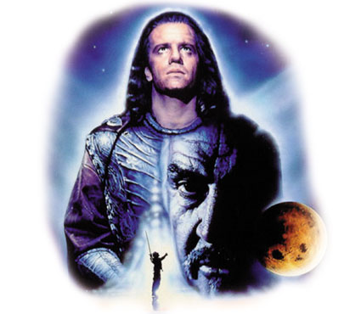

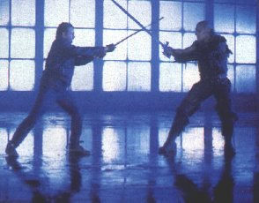

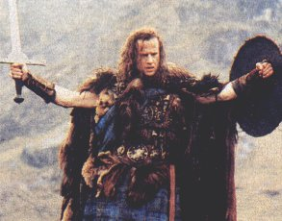
Russell Mulcahy's original saga of immortal Scotsman Connor Macleod, one of a race of immortals who can only be killed when beheaded with a sword. After living in peace for four centuries, he is challenged by an old enemy named Kurgan.
During a fierce sword battle in the 1500s, Connor MacLeod, a simple Scotsman known as a poor fighter, is mortally wounded -- but he does not die. MacLeod learns from the mysterious Ramirez that he is of a race of immortals. These rare knights never age and never reproduce, they can only meet death by the blade of another of their kind. Leaping back and forth through the centuries, MacLeod once again meets the evil Kurgan who nearly killed him 500 years ago.

"From the dawn of time we came; moving silently down through the centuries, living many secret lives, struggling to reach the time of the Gathering; when the few who remain will battle to the last. No one has ever known we were among you... until now."
Genre: Fantasyaction
Duration: 110 min
Starring: Christopher Lambert, Sean Connery, Clancy Brown
Director: Russell Mulcahy
Producer: E. C. Monell
Distributor: 20th century fox
Release Date: 1986
Writer: Gregory Widen
___________________________________________________________________

In the late 13th century, William Wallace returns to Scotland after living away from his homeland for many years. The king of Scotland has died without an heir and the king of England, a ruthless pagan known as Edward the Longshanks, has seized the throne. Wallace becomes the leader of a ramshackle yet courageous army determined to vanquish the greater English forces. At the historic battle of Stirling, Wallace leads his army to a stunning victory against the English. Knighted by the grateful Scottish nobles, Sir William Wallace extends the conflict south of the border and storms the city of York. King Edward I is astonished by the unexpected turn of events. Unable to rely on his ineffectual son Prince Edward, Longshanks sends his daughter-in-law Princess Isabelle to discuss a truce with Wallace.
Horrified that she has been tricked, the Princess sends her servant to alarm Wallace. Unsatisfied in her marriage and attracted to Wallace's noble cause, she becomes his lover and ally.
Wallace is eventually captured and mercilessly quartered, leaving his men without a leader. The army gathers to surrender to the English. Guilt-stricken and tormented, Robert the Bruce vows not to let Wallace die in vain, and leads the heroic Scots into the final battle that wins their freedom.

Genre: Adventure movie
Duration: 177 min
Starring: Mel Gibson, Sophie Marceau, Patrick McGohaan
Director: Mel Gibson
Producer: Mel Gibson
Distributor: 20th century fox
Release Date: 1994
Writer: Randall Wallace

